10hs
SB14
Synchonize FR description custom item field to POS
Go to Record types -> RA-Setting -> More -> Records -> Select item: Supported custom fields -> edit and add:
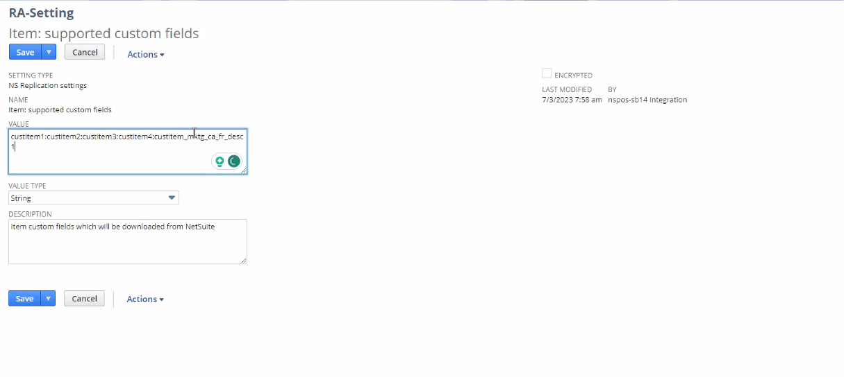
This fields will sync and will take an hour before that syncs to the server.
Items do not immediately sync. So they will need to be pushed.

Go to Inventory items -> Look for item 11000008
This field that we are syncing: custitem_mktg_ca_fr_desc1
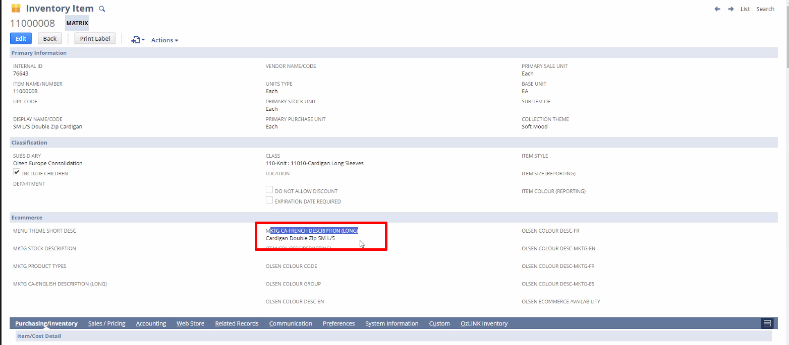
They need to show this under item name on item receipt.

On File Cabinet -> NSPOS -> File System ->RAPOS:
Create a folder for me to use to test:
Create RA-Workstation -> get my id -> create a folder for my workstation alone:
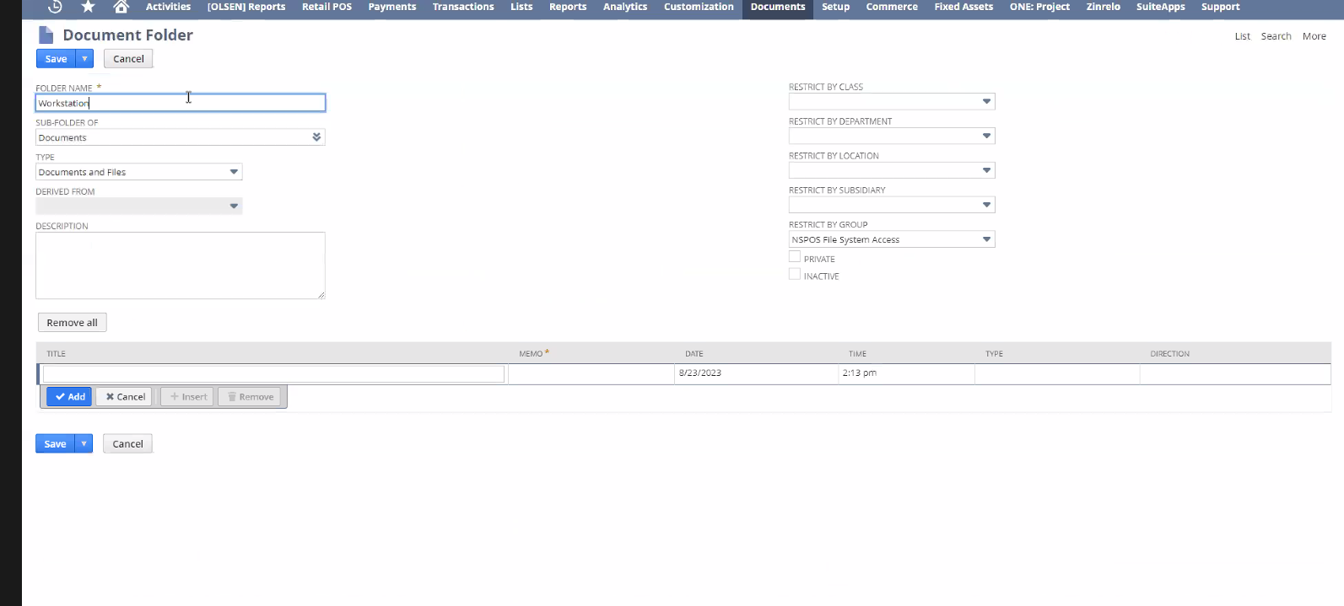
In this case, we use id 37 as name of the folder

What we need
- Use messageHandler
There is an example of a messageHandler, on NSPOS -> File System -> RAPOS -> System -> Startup. File is CustomMessageHandlerDisplayName2.express:
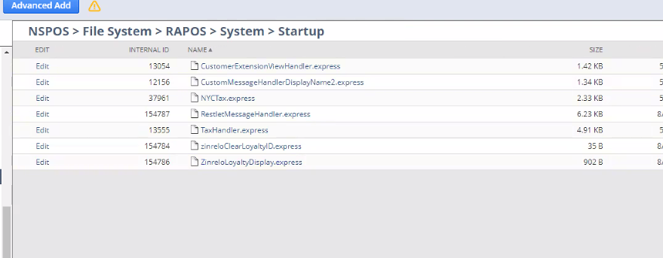
On messageHanlder I will need to:
Get item ID -> Get id for French description (custitem_mktg_ca_fr_desc1) using getItem.extendedProperty
Then if string null or empty do nothing, if not then print.

Be careful to make it run only once, for the item’s internal id, not for tax.
On this folder, this is CustomMessageHandlerDisplayName2.express I will use this file:
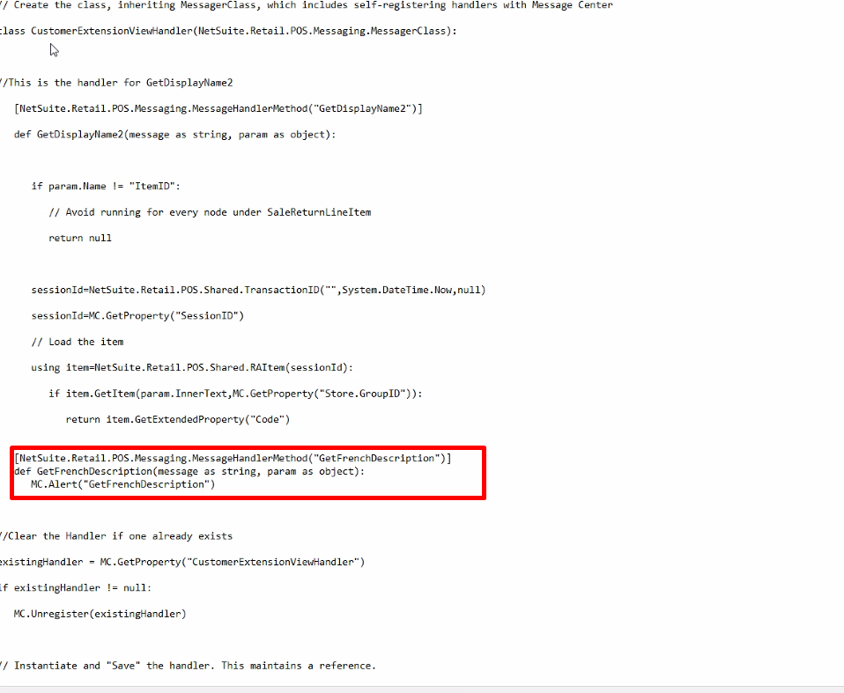
This will take 1hour to sync if I save it.
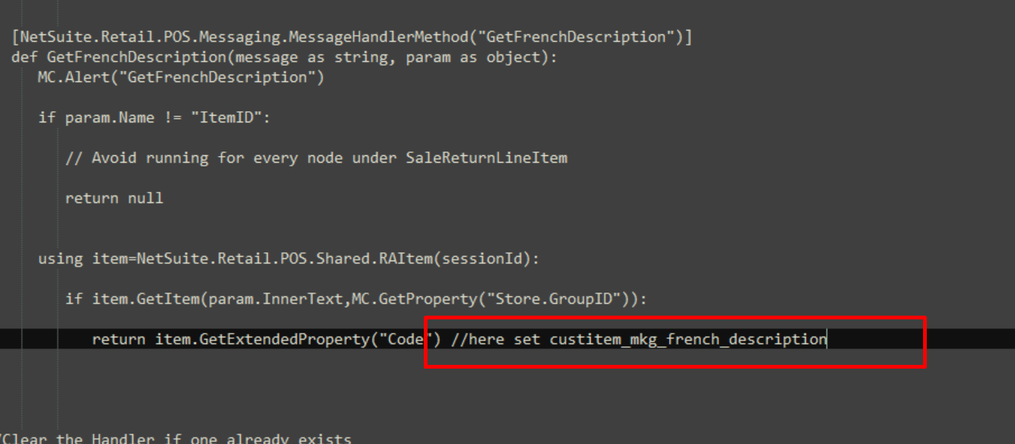
Set here the French description custitem id.

- Use RetailReceipt.RADocument
Go to NSPOS -> File System -> RAPOS -> Documents: download RetailReceipt.RADocument.

We need to call the handler inside this file, in order to get the item id.
Add <Section Name="GetFrenchDescription" Message="GetFrenchDescription"/> to that file:
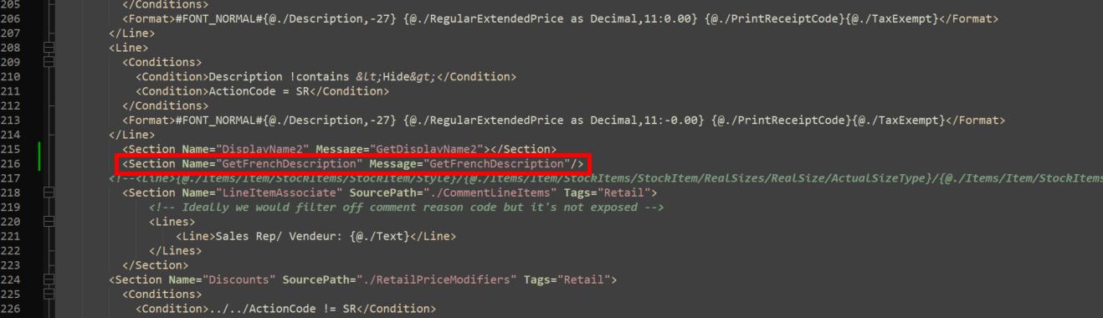
Upload this file on Workstation 137 folder on file cabinet.

Final fixes
I can not have 2 functions inside the messageHandler file. I only need to have one function, since French description is getting null and since it’s null when it calls the function fails due to the nullity.
So we have to use with a parameter that we make sure it’s not null, which is displayName2, so inside that we check if there is something in French description. If it’s something then we add it.
That’s why when I called the handler it would do nothing. Added fixes from mat to file.

To test
Alt + enter to make screen smaller.
Control + f10 -> Select the local settings one -> Workstation settings 11 -> click on the arrow red to enable and change to green, then press on the checkbox to enable debugger printing

Open POS -> add something to the cart -> then just purchase -> print receipt, and then reprint receipt to not do again transactions.
Control + enter -> Write 11000008 to get the item -> amount due -> cash -> Enter

Debug:
Add item -> Control + f12 -> look for ‘express editor’ and then enter:
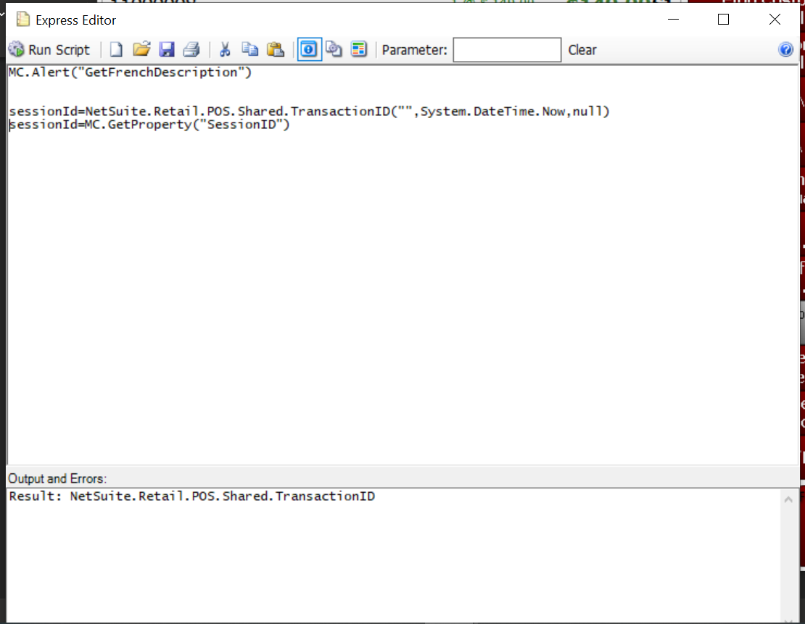
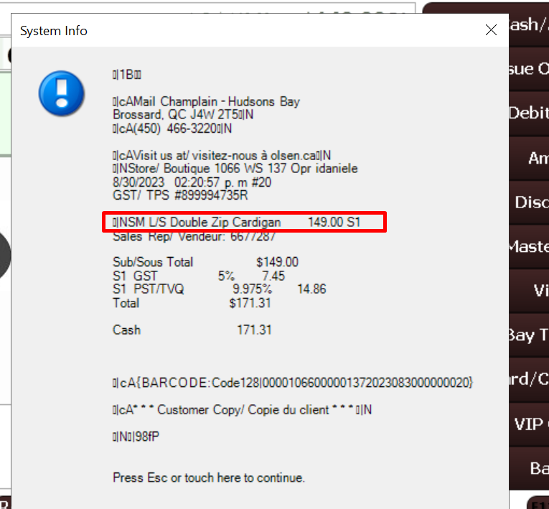
It will show up this receipt.

Questions:
In which section of retailREceipt.RAD ? I added on Line 216 the following to call the messageHandler:
<Section Name="GetFrenchDescription" Message="GetFrenchDescription"/>
Where do I get the id for French description? It’s not the same as custitem_mkg_french_description? YES it is

using item=NetSuite.Retail.POS.Shared.RAItem(sessionId): // is this ok?
if item.GetItem(param.InnerText,MC.GetProperty("Store.GroupID")): //is this ok?
return item.GetExtendedProperty("Code") //here set custitem_mkg_french_description

